MANUAL – REPORTS

① BEGINNING BALANCE
➡️ This feature generates the beginning balance of each Items within the current year.
Navigate the Page to GENERATE REPORTS → Beginning Balance
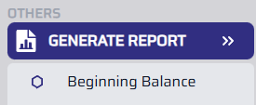

② MONTHLY INVENTORY REPORT
➡️ This feature generates the ending balance of each Items within the select month and year.
Navigate the Page to GENERATE REPORTS → Office and Janitorial Supplies Inventory
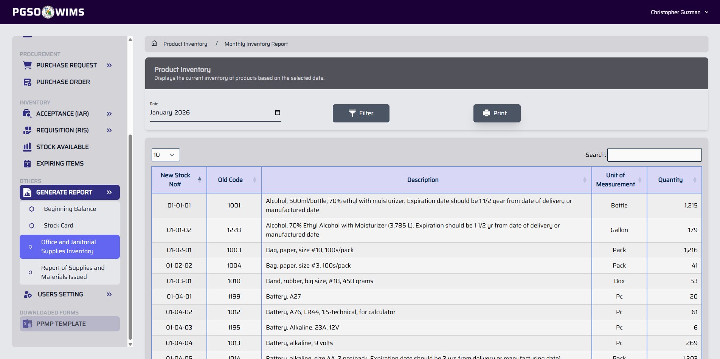
Step 1. Enter the desired year and month.
Step 2. Click the Filter button.
Step 3. Click on the Print button.

③ REPORT OF SUPPLIES AND MATERIALS ISSUED
➡️ This feature generates a report listing all items along with their issuance transactions for the selected period, including the total quantity issued during that time.
Navigate the Page to GENERATE REPORTS → Report of Supplies and Materials Issued
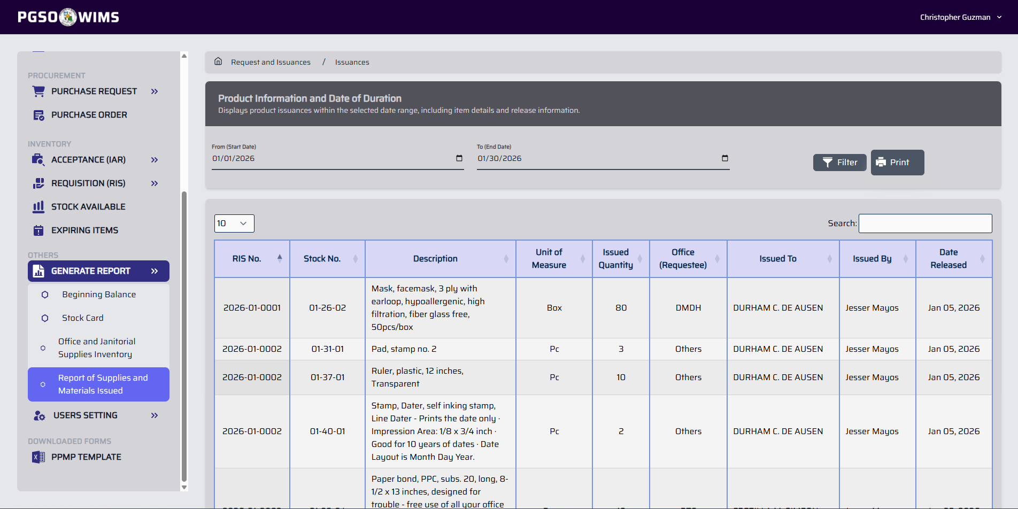
Step 1. Enter the Start Date and End Date.
Step 2. Click the Filter button.
Step 3. Click on the Print button.

④ STOCK CARD
➡️ This feature generates a summary report listing all transaction made on an item for the selected period.
Navigate the Page to GENERATE REPORTS → Stock Card
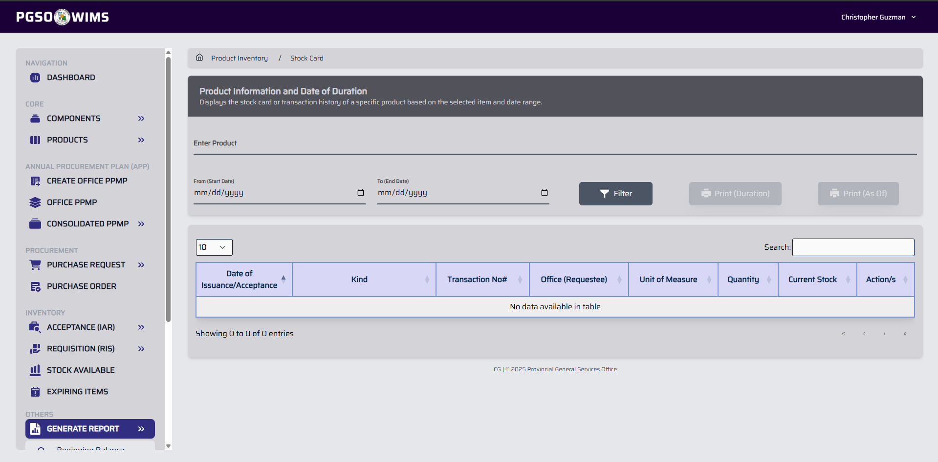
Step 1. Enter the required information in the input fields. For the Product field, use the item code or any keyword related to the item.
Step 2. Click the Filter button.
Step 3. Click on the Print button.

